**Big Mountain Resort Profit Recovery**

Fatima Soytemiz

# A Problem Statement

Big Mountain Resort decided to install an additional chair lift to increase the number of visitors to the facility. The chair increases operating costs by $1.54 M. The current profit margin is 9.2%, and investors would like to protect the current margin.

# Modeling

A dataset was provided containing information on 330 ski resorts across North America. The metadata is summarized in figure 1.

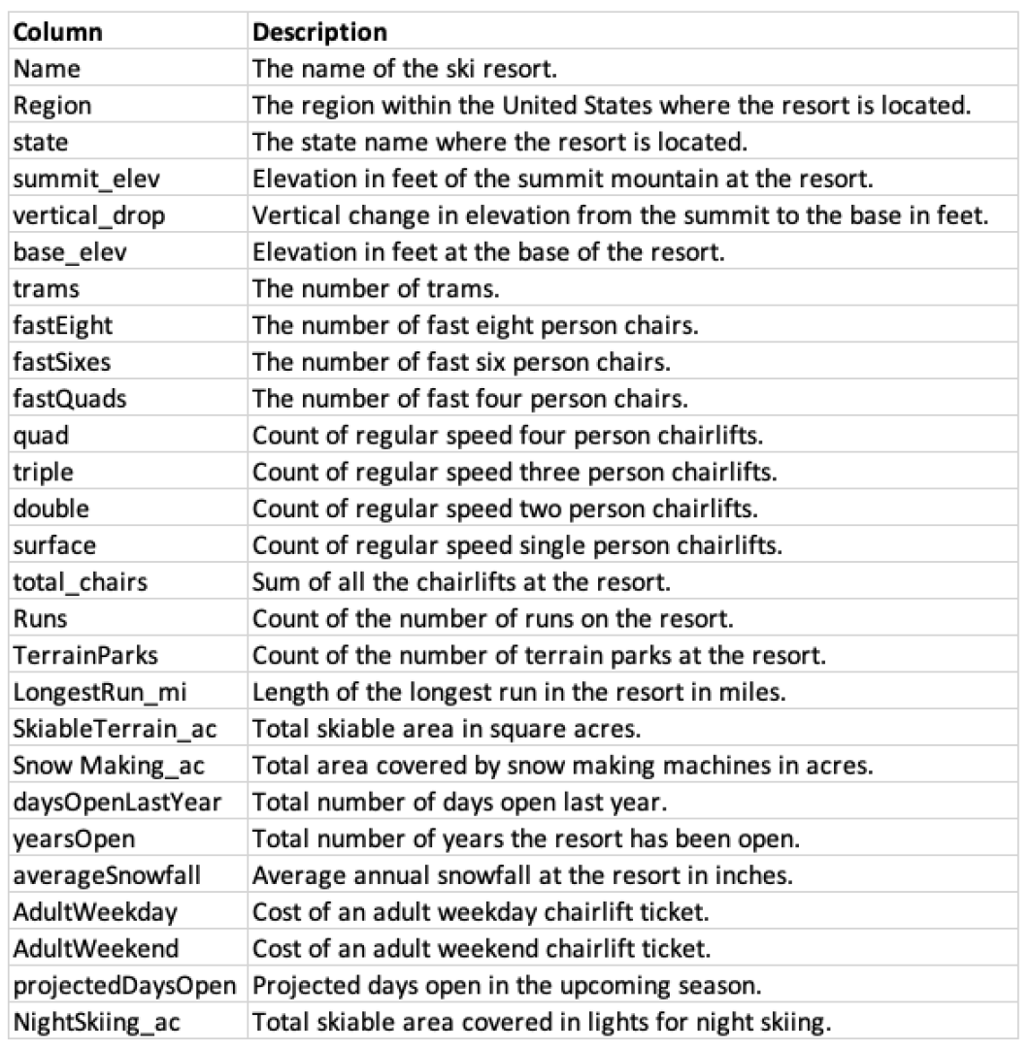

*Figure 1. Dataset*

The goal was to determine if profits could be maintained at 9.2% by reasonably adjusting adult weekend price. To do this, a model was built to predict what the price of an adult weekend ticket should be at Big Mountain Resort given its features compared to other ski resorts across North America.

The dataset was scrubbed prior to model training. Null values were filled, outliers removed, duplicate rows dropped. An additional feature was added to the dataset via k-means clustering to categorize the ski resorts into 3 separate related bins.

A regression model was implemented, attempting several modified iterations. The final model that was executed dropped the ‘state’, ‘summit_elev’, ‘base_elev’ features from the data set. The ‘summit_elev’, ‘base_elev’ are highly correlated features and they don’t contribute to our model. The explained variance score and mean absolute error from testing this model are displayed in table 1.

| **Explained Variance** | **Mean Absolute Error** | **Features Dropped** |
| --- | --- | --- |
| 0.9280 | 5.4322 | state, summit_elev, base_elev |

*Table 1. model performance metrics*

# Results

The model was executed and the appropriate adult weekend ticket price for Big Mountain Resort was predicted to be $88.87. The current price is $81.00. This could protect the current profit margin at 9.2%, and potentially increase it.